80mm 12V Brushless DC Cooling Fan
80x80x25.4mm High Speed Sleeve Bearing
Dynatron (Top Motor) DF1208SH or DF128025SH
80-mm ( 8-cm ) System Fan
FN-8025-2C-SH-DY
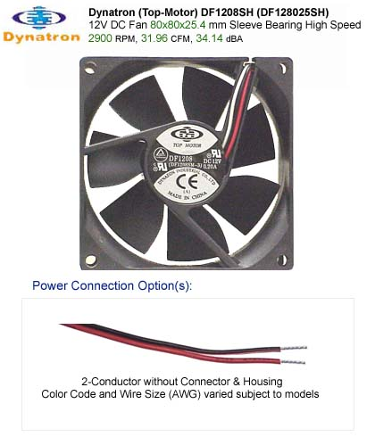
80mm 12V Brushless DC Cooling Fan
80x80x25.4mm High Speed Sleeve Bearing
Dynatron (Top Motor) DF1208SH or DF128025SH
80-mm ( 8-cm ) System Fan
Size: 80x80x25.4mm
Bearing System: Sleeve Bearing
Rated Voltage: 12V
Input Current: 0.25A
Input Power: 3.00W
Speed: 2900 +/- 10% RPM
Air Flow: 31.96 CFM
Static Pressure: 3.16 mm-H2O
Noise Level: 34.14 dBA
click here for Dynatron / Top-Motor Item Numbers Comparison Chart

