Please read before using this equipment
DRAGON
MODEL : SS-485H
OWNER'S MANUAL
10 METER AM/FM/SSB MOBILE RADIO

FEATURES
Your SS-485H 10 Meter Amateur Transceiver is a two-way 28 MHz radio for use in your vehicle or, you can connect a DC power supply and base station antenna to set up a base station in your home. You can also connect optional equipment to your transceiver, such as an external speaker. With the right accessories, your transceiver also becomes a public address system.
Your transceiver also has these advanced features:
Phase-Locked Loop (PLL) Frequency Synthesizer - provides highly accurate and stable tuning.
Single Side Band Mode - gives you twice the number of channels, and increases the effective communications range.
Scan - searches for active channels.
Large, Illuminated, Digital Display - clearly shows the channel number, frequency, and incoming signal strength.
Built-in, Ceramic Filters - ensure superior channel selectivity and freedom from adjacent channel interference.
External Speaker Jack - lets you connect your transceiver to an external speaker,
Built-in Automatic Modulation Control - ensures a constant RF modulation level,
Automatic Gain Control - maintains a constant volume level, regardless of the signal strength.
Switchable Noise-Blanker - reduces interference from ignition systems, motors, and other electrical equipment.
Squelch Circuit - compensates for signal fading and eliminates signal chopping.
RF Gain Control - lets you adjust the receiver gain to match the strength of the received signal.
Clarifier Control - improves reception of SSB (single sideband) signals.
Universal Mounting Bracket - lets you mount your transceiver securely in your vehicle or on a table or shelf in your home,

INSTALLATION

ATTACHING THE MICROPHONE HOLDER
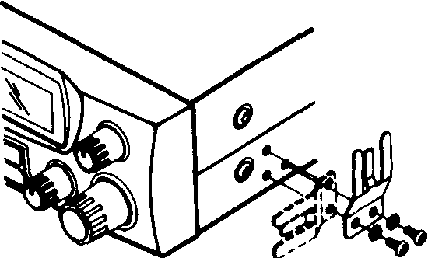

You can connect the microphone holder to either side of the transceiver or to another location in your vehicle.
To attach the holder to either side of the transceiver, horizontally or vertically secure the holder to the side using the supplied screws and lock washers.

To attach the holder to another location in the vehicle, such as the dashboard, follow these steps.
1. Using the holder as a template, mark the positions for the mounting screw holes at the desired location.
2. At each marked position, drill a hole slightly smaller than the supplied mounting screws.
Caution : Be careful not to drill into anything behind the mounting surface.
3. Attach the holder at the mounting location using the supplied machine screws and lock washers.

MOUNTING THE TRANSCEIVER
The most common mounting location for this transceiver is under a vehicle's dashboard. However, if you use the SS-485H as a base station, you can place it on a desk, shelf, or table (see "using the Transceiver as a Base Station").
If you are mounting the transceiver in a vehicle, choose a location where:
* You can easily reach the transceiver,
* Wires and cables are clear of the vehicle's pedals or other moving . parts.
* The transceiver is not directly in front of heating vents,
* All wires and cables can reach their connection points.
Caution : If you the transceiver in a vehicle, mount it securely to avoid damage to the transceiver or vehicle or injury to anyone in the vehicle during sudden starts or stops.

Follow these stops to mount the transceiver using the supplied hardware.
1. Using the mounting bracket as a template, mark the positions for the screw holes on the mounting surface
2. In each marked location, drill a hole slightly smaller than the supplied mounting screws.
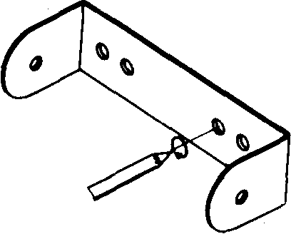

Caution : Be careful not to drill into objects behind the mounting surface.
3. Using a Philips screwdriver, attach the mounting bracket to the mounting surface with the supplied mounting screws and flat washers.
4. Attach the transceiver to the mounting bracket using the supplied rubber washers and mounting knobs.
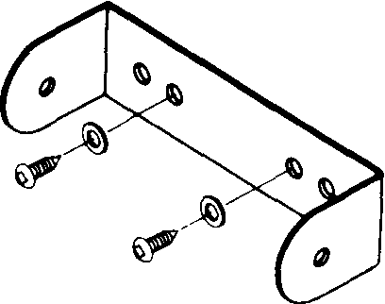

CONNECTING AN ANTENNA
There are many different types of transceiver antennas for mobile transceivers. Each antenna type has its own benefits, so choose the one that best meets your needs.
Note : If you are using this transceiver as a base station, see "Using the Transceiver as a Base Station".
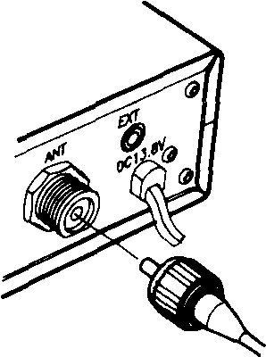

When you choose an antenna, keep in mind that for the best performance you should mount the antenna:
* As high as possible on the vehicle
* As far as possible from sources of electrical noise
* Vertically
Once you choose an antenna, follow its mounting instructions. Then route the cable to the transceiver and connect the cable to the ANT jack on the back of the transceiver,
Rubber Washers
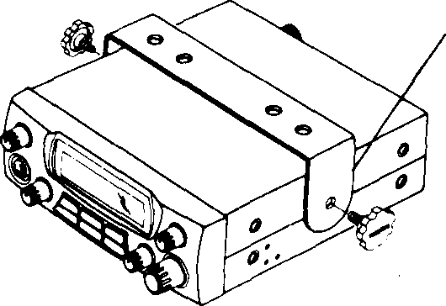

Cautions :
* Avoid routing the cable next to sharp edges or moving parts, which might damage the cable.
* Do not run the cable next to power cables or other radio antenna cables.
* Do not run the cable through the engine compartment or other areas that produce extreme heat.
To achieve your radio's maximum range, the antenna's Standing Wave Ratio (SWR) must be adjusted. You can use an SWR meter (not supplied) to adjust the SWR for your antenna.
Follow the instructions supplied with the SWR meter and antenna to adjust your antenna's SWR to the lowest possible value, SWR values of 2.0:1 are generally acceptable, with readings of 1,5:1 or lower being more desirable,
Note : Using your radio with an antenna adjusted to a high SWR value might eventually damage your radio.

CONNECTING THE MICROPHONE
1. Insert the microphone's plug into the microphone jack on the front of the transceiver.
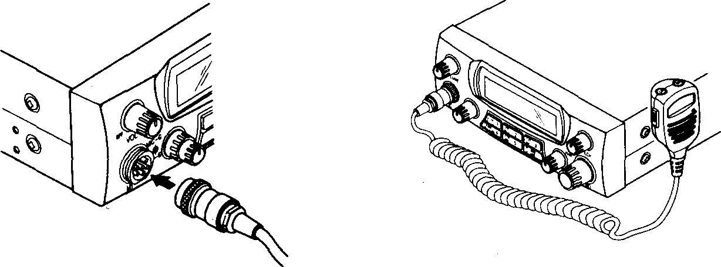
2. Slide the microphone into the microphone holder,

CONNECTING OPTIONAL SPEAKERS

You can connect your transceiver to an external speaker.
Note : When you connect an external speaker, the transceivers internal speaker disconnects.
USING AN EXTERNAL SPEAKER
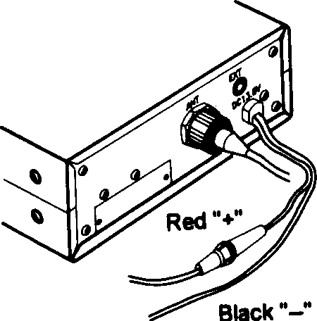
The external speaker you use with the transceiver should have an impedance of 8 ohms and be able to handle 3 to 10 watts of power, The speaker cable must have a 1/8-inch plug. To connect the external speaker to the transceiver, insert the speaker cable's plug into the EXT jack on the back of the transceiver.

USING VEHICLE BATTERY POWER
Follow these stops to connect the transceiver to vehicle battery power

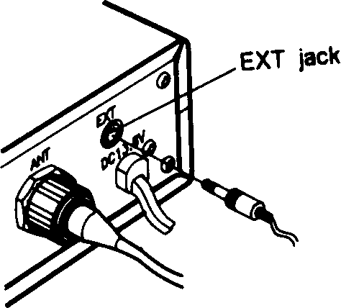
Connect the red wire (with the inline fuse holder) on the back of the transceiver to a point in your vehicle's fuse block that has power only when the ignition is in the ACC(accessory) or ON position,
2. Connect the black wire to a metal part of the vehicle's frame (chassis ground).

Caution : wire to a to any vehicle's part.
Do not connect the black non-metallic (plastic) part, or
part insulated from the chassis by a non-metallic

USING THE TRANSCEIVER AS A BASE STATION

Although this transceiver is designed mainly for mobile use, you can use it as a base station with an AC power source, For base station installation, you need these items.
* 12-volts DC power supply that can supply at least 10 amps.
Caution : Most 12-volt DC power supplies plug into a standard AC outlet to produce DC power. Before connecting your Radio to a 12-volt DC power supply, read and follow the instructions included with the power supply.
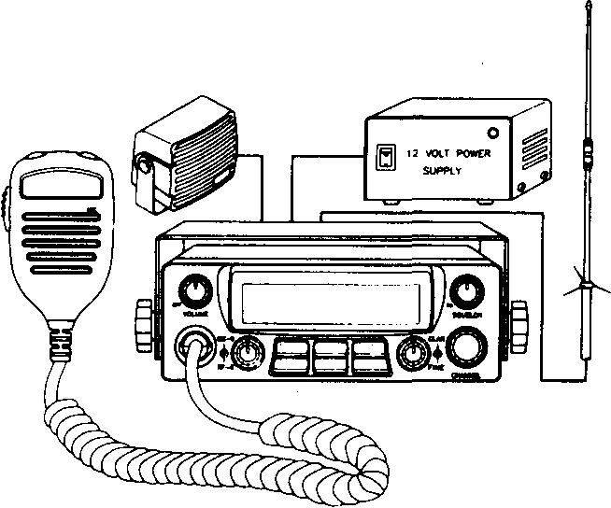
* Base station antenna
* Coaxial antenna cable and connectors
* External 8-ohm speaker
Follow these steps to install the transceiver as a base station.
1. Mount the base station antenna as a described in its owner's manual.
Warning : Use extreme caution when you install or remove a base station antenna. If the antenna starts to fall, let it go, It could contact overhead power lines. If the antenna touches a power line, contact with the antenna, mast, cable, or guy wires can cause electrocution and death. Call the power company to remove the antenna. DO NOT attempt to do so yourself.
2. Connect the antenna to the ANT jack on the back of the transceiver.
3. Connect the transceiver's black power wire to the negative (-) terminal on the DC power supply.
4. Connect the transceiver's red wire (with the in-line fuse) to the positive (+) terminal on the DC power supply.
5. Connect the DC power supply to a standard AC outlet.

RADIO FUNCTIONS
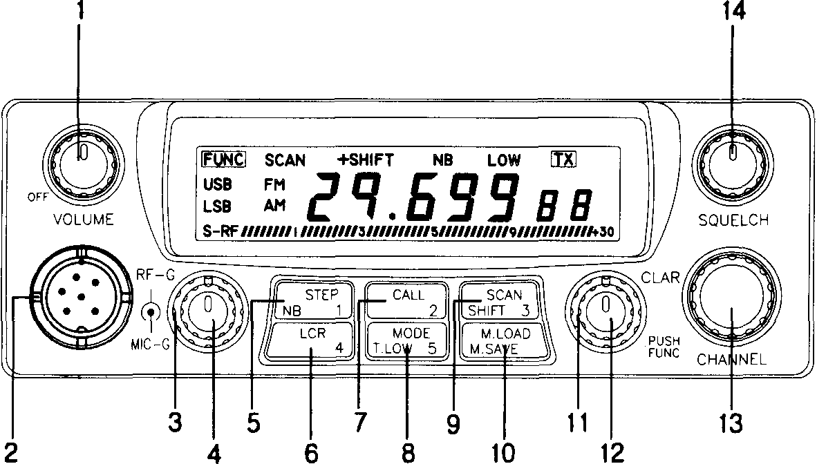
1. POWER ON/OFF SWITCH
Turns radio on and OFF and adjusts volume.
2. MICROPHONE INPUT
6 pin socket for push-to-talk microphone.
3. RF GAIN CONTROL
Control the receiver sensitivity to reduce interference. To decrease RF gain, turn the knob counter clockwise. For the maximum receiver sensitivity, the RF GAIN control must be rotated to extreme clockwise.
4. MIC GAIN CONTROL
This control provides the proper or desired modulation,

5. STEP/NB/MEMORY 1 SWITCH
FUNCTION OFF ;
STEP FUNCTION - This switch is used for select one of the frequency step : 1 KHz/10KHz/100KHz
1 KHz : Set 1 KHz digit of the desired operating frequency. 10KHz : Set 10KHz digit of the desired operating frequency. 100KHz : Set 100KHz digit of the desired operating frequency.
FUNCTION ON ;
NB FUNCTION - If your reception is disturbed by interference from impulse type noise (ignition noise and other electrical noise press NB to reduce or eliminate the noise). * Save channel in the memory 1 with MEM switch.

6. LOR/MEMORY 4 SWITCH
FUNCTION OFF ;
LCR (Last Channel Recall) FUNCTION - Press LCR to return to the last channel that was used for longer than 3 seconds or was transmitted on
* Load channel in the memory 4 with MEM switch.
FUNCTION ON ;
* Save channel in the memory 4 with MEM switch.
7. CALL/MEMORY 2 SWITCH
FUNCTION OFF ;
CALL FUNCTION - This switch is used to access a reprogrammed frequency (memory 2)
* Load channel in the memory 2 with MEM switch.
FUNCTION ON ;
* Save channel in the memory 2 with MEM switch,
8. MODE/T-LOW/MEMORY 5 SWITCH
FUNCTION OFF ;
MODE FUNCTION - Select one of the operation modes AM/FM/USB/LSB.
* Load channel in the memory 5 with MEM switch.
FUNCTION ON ;
T-LOW FUNCTION - This switch activates tone low (high cut) circuits,
* Save channel in the 5 with MEM switch.
9. SCAN/SHIFT/MEMORY 3 SWITCH
FUNCTION OFF ;
SCAN FUNCTION - Set the scan mode on/off in RX-mode.
* Load channel in the memory 3 with MEM switch.
FUNCTION ON ;
SHIFT FUNCTION - Press the shift switch to select the direction : +SHIFT/
*SHIFT. Press more than 3 seconds the SHIFT switch to select to off-set step : 0~ 990KHz.
* Save channel in the memory 3 with MEM switch.
10. MEM SWITCH
FUNCTION OFF ;
MEMORY LOAD FUNCTION - Load one of the 5 memory channels with 5 numeric key,
FUNCTION ON ;
MEMORY SAVE FUNCTION - Save one of the 5 memory channels with 5 numeric key.
* Load channel in the memory 1 with MEM switch.
11. CLARIFIER CONTROL
This control provides an adjustment for turning in stations which are slightly OFF frequency, to optimize the AM and SSB reception.

12. FUNC SWITCH
BRIEF PUSH : This switch activates the secondary function of double function switch.
13. CHANNEL SELECTOR SWITCH
This Rotary switch selects one frequency in RX mode, but frequency is not activated in TX mode.
14. SQUELCH CONTROL
Used to quiet the receiver during absence of receive signals Sensitivity to incoming signals is fully -adjustable,
TONE CALL SWITCH ON THE MICROPHONE
Most repeaters require a 1750HZ Tone-burst for initial access in FM mode. (Do not operated in AM mode and SSB mode).
BEEP/TONE
Turning on power switch while keeping PTT key pressed sets beep mode on/off.

DISPLAY PANEL FEATURES : Illustrated below are all the VISUAL INDICATORS that appear on the display, and the corresponding feature function that they associate with.
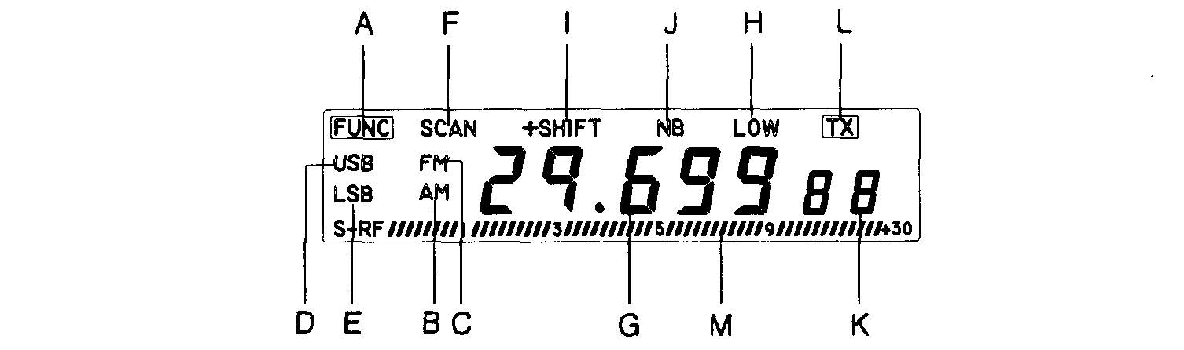

LIQUID CRYSTAL DISPLAY PANEL : The state of art liquid crystal panel provides the user with a visual information center on the operation and status of the SS-485H.

CAUTION : Due to the components inherent in them, liquid crystal displays should not be subjected to extremes of temperature or humidity. If the unit is exposed to temperatures below -20°C(-5°F) or above +601:
(+140'F), the display may temporarily cease to function properly, and in some cases, could result in permanent damage. Do not subject radio to extreme conditions, such as closed automobile in direct sunlight or continuous sub zero temperatures.
All liquid crystal displays have a preferred viewing angle when the display contrast is at a maximum. The best viewing point will vary by user, depending on such variables as temperature, humidity, battery condition, and the actual users eyesight.

A) Function Mode : Indicated the "Func" button has been selected, which allows for operation of many of the various features.
B) AM : Indicates AM mode operation.
C) FM : Indicates FM mode operation.
D) USB : Indicates Upper Sideband mode operation.
E) LSB : Indicates Lower Sideband mode operation.
F) SCAN : Indicates that the radio is in the "scan" mode which works in conjunction with all frequency and five memory locations.
G) Frequency Readout :. Displays the corresponding frequency associated with the channel you are communicating with.
H) LOW : Indicates that the Tone Low features has been turned on,
I) SHIFT : Indicates that the SHIFT (+ and -).
J) NB : Indicates that the Noise Blanker features has been turned on.
K) "L" : Indicates that memory retrieval mode has been activated. "S" : Indicates that the radio is in the "Memory Store" mode, ready to receive a channel into one of the memory locations.
L) TX : Indicates that the radio is in the transmit mode.
M) S/RF LEVEL METER : In receive mode, this meter displays incoming signal strength. In the transmit mode this Meter displays RF power.

NOTES ON SSB RECEPTION
* When you first listen to an SSB signal, you probably will not be able to understand it. The voice might sound distorted or low and guttural. In either case, slowly turn CLARIFIER signal into its natural voice total range,
* An SSB signal produces a fluttering, unintelligible sound when received in the AM mode. Set the mode switch to either LSB or USB, and adjust CLARIFIER.
* If the voice is still not intelligible, it might be an SSB signal operating on the other sideband - try the other SSB mode.
* You can tune AM signals when the mode switch is in the USB or LSB position. Adjust CLARIFIER to eliminate the steady tone caused by the AM carrier signal.

TROUBLESHOOTING
If at any time you suspect that your transceiver is not working as it should, refer to the following chart to see if you can eliminate the problem,
Symptom | Solution
Trouble with reception | Too much squelch? Adjust as need.
Trouble with reception | Radio not on operating channel? Switch to active channel.
Trouble with reception | Microphone connected? Secure connections
Trouble with reception | Antenna connected? Secure connections.
Trouble with reception | Mode switch setting? Select appropriate positi on (AM, LSB, USB).
Trouble with transmission | Transmission cable connected to antenna? Secure antenna connector.
Trouble with transmission | Antenna fully extended? Extend to full length.
Trouble with transmission | All connections free of corrosion? Clean and tighten.
Trouble with transmission | Talk button fully pressed in? Press completely.
Trouble with transmission | Microphone connector loose? Firmly press completely.
Radio dose not work at nil  ^ulll | Power connected? Secure connections.
Radio dose not work at nil  ^ulll | Microphone connected? Secure connections.
Radio dose not work at nil  ^ulll | Fuse needs replacing? Replace with identical fuse.

REDUCING NOISE
Because your transceiver is exceptionally quiet, any noise you hear is probably from an external source in your vehicle such as the alternator, another radio or speak plugs.
You can determine the noise's source by turning off the engine and operating the transceiver with your vehicle's ignition set to ACC. If the noise is reduced, the problem is in your vehicle's ignition or electrical system.
Here are a few hints to help you reduce or eliminate such noise :
* Make all transceiver power and antenna wires as short as possible.
* Route the power wires away from the antenna wires.
* Be sure that the chassis ground connection is secure.
* Replace old ignition wires with new, high-voltage, noise suppression wires.
* Install noise suppressors on your speak plugs, or install new spark plugs that have built-in noise suppressors,
* If problems persist, check your alternator/generator and regulator gauges. You can reduce the noise from these sources by using bypass capacitors at the various output voltage points,

MAINTENANCE
Your Transceiver's is an example of superior design and craftsmanship. The following suggestions will help you care for your transceiver so you can enjoy it for years.
Keep the transceiver dry. If it gets wet, wipe it dry immediately. Liquids can contain minerals that can corrode electronic circuits.
Handle the transceiver gently and carefully. Dropping it can damage circuit boards and cases and can cause the transceiver to work improperly.
Use and store the transceiver in normal temperature environments. Temperature extremes can shorten the life of electronic devices, damage batteries, and distort or melt plastic parts.
Keep the transceiver away from dust and dirt, which can cause premature wear of parts.
Wipe the transceiver with a damp cloth occasionally to keep it looking new. Do not use harsh chemicals, cleaning solvents, or strong detergents to clean the transceiver.

REPLACING THE FUSES
The SS-485H 10-amp in-line fuses help protect your Transceiver from power
surges and short circuits.
* If there is no power, check the red wire's fuse, If the red wire's fuse is
blown, use a 10-amp, fast-acting glass fuse.
Follow these steps to replace the fuse.
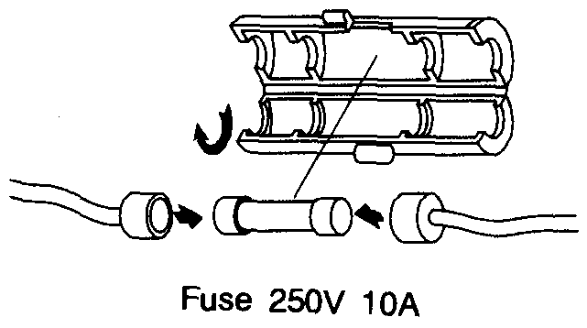
1. Make sure the power source and Transceiver are both off.
2. Hold the fuse holder with one hand, then push the locker cover and rib each other opposite direction with thumb finger and second finger as twist,
3. Remove the old fuse and inspect its condition. If it is blown and requires replacement, insert a new one of the same type and rating. If it is not blown, reinsert it.

SPECIFICATIONS
GENERAL
Frequency Range................................................................... 28.000 to 29.699MHz
Frequency Control..........................................Phase Lock Loop (PLL) synthesizer
Frequency Stability.,................................................................................... +/-400Hz
Frequency Tolerance.......................................................................................0.003%
Emission Mode,........................................................ A3E(AM), F3E(FM), J3E(SSB)
Microphone.........,,.....,,....,.......,...,........,..,,...,...Plug in electret; with push-to-talk
switch and coiled cord Input Voltage...........................................13.8V DC nominal, 16V max. 12V min
Size (WDH).. ..,,.......,,.......,,..„.......,...,.......,,......„..,,...,..,, 2 3/64" x 6 1/2" x 7 41/64"
Weight...........................................................................................2.65LBS (1.2Kg)
Antenna Connector...................................................80-239 50ohm unbalanced
Speaker.......................................................................................,..,.....,.8ohm, 3watts
TRANSMITTER
Power Output.......................................................AM 6W, FM 25W, SSB 25W PEP
Spurious Emission................................................................................65dB or better
Current Drain No Modulation...................................................AM less than 3.5A
FM less than 6.0A SSB less than 1.0A Current Drain at Max Power....................................................AM less than 3.5A
FM less than 6.0A SSB less than 6.0A Modulation Frequency Response
(1KHz, OdB Reference)...............................Lower, at 450Hz, AM -6dB, SSB -6dB
Upper, at 2.5KHz, AM -6dB, SSB -6dB Microphone Sensitivity........................................................AM 4mV for 50% mod
FM 4mV for 1KHz DEV SSB 4mV for lOwatts PEP
RECEIVER
Max Sensitivity for 6dB S/N..........................................AM 0.5uV, FM/SSB 0.25uV
Sensitivity for 10dB S/N................................................AM 0.5uV, FM/SSB 0.25uV
Overload Audio Fidelity at 6dB Down,.........................................450Hz~2100Hz
Adjust Channel Selectivity.....,........,,..,...,......,,...,....„.......AM/FM 60dB, SSB 70dB
Image Rejection (5,6MHz)..........................................Typically better than 90dB
IF Rejection,,........,,....,...,...,...,,.......,,.......,,,.,,..,,,..,....,,,,..,,............,.,,.70dB or better
Max Audio Output Power....,.......,,........,....,..,.......................AM/FM/SSB 2.5wat+s
Squelch Range......................................................Adjustable from 0.5uV to ImV
Receiver Clarifier Range...............................................................+/-1 KHz Variable
Dynamic Range.........................................................................................65dB (SSB)

