
Triac and SCR (Thyristor) Tester

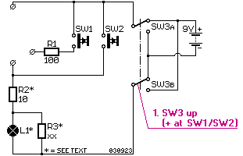

Triacs and SCRs (thyristors) come in different shapes and it can sometimes be difficult to know which lead is what. With this circuit, it is possible to find out if the device is still functioning well and how to connect it.
Start putting SW3 upward and connect the 3 leads of your triac/SCR. Push SW1 and when everything is connected well and the semiconductor is in good condition, L1 will light. If L1 doesn't light, swap connections until it does. If L1 doesn't light at all, it means the semiconductor is defectif. If L1 lights, push SW2. This switch takes over the "hold" current of the device, when released, L1 will extinguish. (A triac/SCR needs a certain "hold" current, that is why L1 should be no less than 300mA.)
Switch SW3 to the other position. Push SW1. If nothing happens, you have a good SCR. If L1 lights again, push SW2. When released, L1 should extinguish. This means you have a good triac.
This way, you can check whether a semiconductor is working and whether it is a triac or a SCR plus what the leads are.
Parts List
Unless otherwise stated, resistor wattage = 0.25W.
- R1 = 100Ω  - R2 = 10Ω 1W  - R3 = to be calculated  if the lightbulb is less than 300mA  - L1 = lightbulb 6V to 6V5, 300mA. | - SW1, SW2 = momentary,  normally open  - SW3 = DPDT  (double pole, double throw)

To staybank circuit exchange Circuit Index
© Copyright 2000- 2010 by staybank circuit exchange

