This is a lesson on recycling. Everything here was built from scrap microwave ovens with the exception of the bearings and pivot mount also the plywood. Microwave ovens have an abundant source for the materials used in making an alternator and the rest of the components of an actual working wind generator. They contain large 2 1/4" round magnets ( 2 in each unit - in the magnetron ) plenty of sheet metal ( cases ) and even useful wire in the transformer. You could actually use the transformer metal as the stator laminates.
WARNING: Microwave ovens utilize very high voltage to drive the magnatron unit. Care should be taken when disassembling them and the capacitor should be discharged prior to reaching inside....
This will probably dry up my source for microwaves but you can call any appliance repair and find many microwaves free for the asking. I called one shop just to inquire about the possibility of getting a couple, they told me they had a few. I went over there and he directed me to the warehouse where there was about 40 of them. He looked at me, smiled and said if you take one you have to take them all.... I really think he was kidding but 3 trips later they were all in my shop. I tore them down and started saving all the little parts that could prove to be useful for other projects... screws, rubber feet, micro switches, fans, transformers,etc... ( I don't throw nothing away ) and about 80 magnets.
I started out by cutting an 10" disc out of plywood, cut strips of steel out of the case to make the laminates. Coiled the strips to form the stator and epoxied them to the board. I used strapping tape on all the metal strips which served two purposes, One to help hold the whole thing together and Two to isolate them from each other thus reducing eddy currents. I machined 24 slots to hold the wire and started the winding process.
Below are the beginning shots of the process...
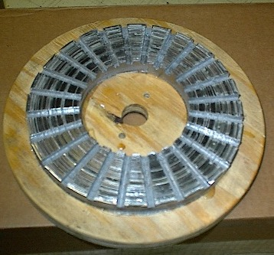
There is 60 feet of 3/4" steel in this stator. The stator is 8" in diameter and 2" wide. Below show the winding in process...
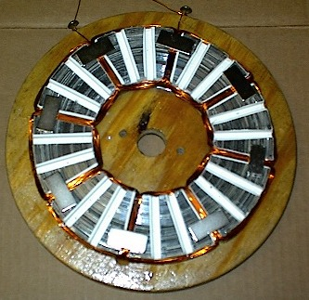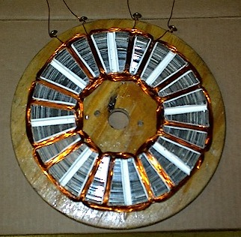
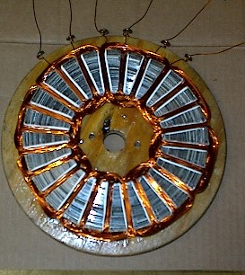
The white inserts are made out of old milk cartons to isolate the wires from the steel. Each picture shows each of the 3 phases being placed into the slots. This was wound on the stator itself and each phase is wound as if it were a single phase unit. There are 36 wires in each slot making up 18 turns per coil. And yes I know I blew my rule number one... Keep it simple. The slots really are unnecessary but do help to bring the power and efficiency up and since this is a small turbine ( 28" diameter) I needed all the efficiency I could get.
Initial testing of the alternator came out quite promising. At 600 rpm the open voltage was 29.6 volts. My goal here is to make a very small turbine that will produce 150 watts in a 30 mph wind. After many doodles and calculations, 3 or 4 pads of paper later this is what I've come up with. I'm not going to show the turbine in great detail and all the alternator functions will be left out as there is a patent pending on this unit, although won't be manufactured out of microwave ovens in the end.
Below is the preliminary installation of the stator on the pivot head of the turbine. You can see the coils are shrouded and sealed...
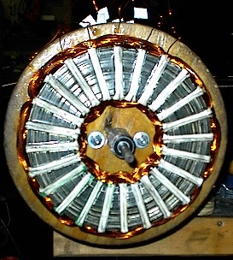
This next picture shows the microwave magnets taken from the "magnetron" and setting on an 8" steel disc. Also shows the octagon plywood rotor ( 14" ) and the blades mounted on the rotor assembly. Using steel blades makes the rotor quite heavy and would be extremely susceptible to high winds and over speeding. This is simply a test unit and will not be installed permanently...
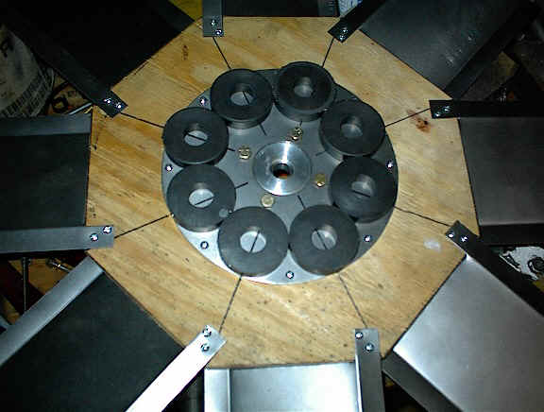
I've calculated the stress point to be somewhere around 1100 to 1200 rpm before the wood structure would come apart, this being winds at around 50mph. This could be changed by adding longer mounting tabs on the blades and installing 3/16" bolts instead of the sheet screws. The blades are 7" tall and 8 of them are installed on the plywood. Each blade is set at an angle of 10 degrees. The metal came from a large microwave case and was bead blasted and is now ready for paint. The plywood will be coated in poly resin ( fiberglass resin ) to seal and waterproof the assembly, the magnets will be resin'd in also.
After all was assembled, unfinished and semi balanced, testing went fairly well. The performance of the "microwave" turbine was below my projected output but not bad for its size. The maximum output achieved was 90 watts in a 30mph wind. It performed well in lower winds giving 22 watts in a 14mph wind. No powerhouse by any means but for its size ( 28" - not much bigger than a basic box fan) it did quite well.
All in all a good lesson in scavenging and making due with what is available. The entire project cost about 8 bucks not including any labor. Comes out to about 8 cents a watt....
I've dismantled this unit since and have added a different rotor with 6 blades. Initial tests on the new one are providing much better results but still about 20watts under my goal here. Initial testing showed an overall efficiency of 23%. The eight bladed ( steel blade) was giving me about 11% ( not impressive by any means). I'll post some images of the new rotor shortly.....
The blades are carved from standard 2x4 board scraps and the center was brought down from the 14" octagon to a 10 circle allowing for more blade area....
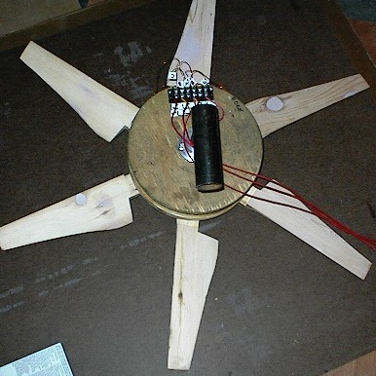
Still only 30" in diameter, testing was done in a 14 mph wind and the results are coming out good. Unloaded the blades run around 720 rpm and with a load 570 rpm. Using a slightly dead battery with a 50 watt load its making 11.75 volts at 1.7 amps ( total of 19.9 watts ). The total available watts for that area of blade is 77.78 so that makes the overall efficiency of around 25%. It will make about 170 watts in a 30mph wind and the efficiency drops to around 22%. Still just over 13 amps at 12.7 volts... not bad for a tiny turbine...
Still testing various configurations and shields.....

