TR0230 Information
  TRAFO: SAMSUNG FUH29V002 - FBT és egyéb transzformátorok
  RoHS
  Kiváltója:
  Kiváltója: | 32"
  Kiváltója: | Chassis: S62B
  Info4: | AA26-00244A
  Information for order: (03.24 17:37 2011)
  No longer available
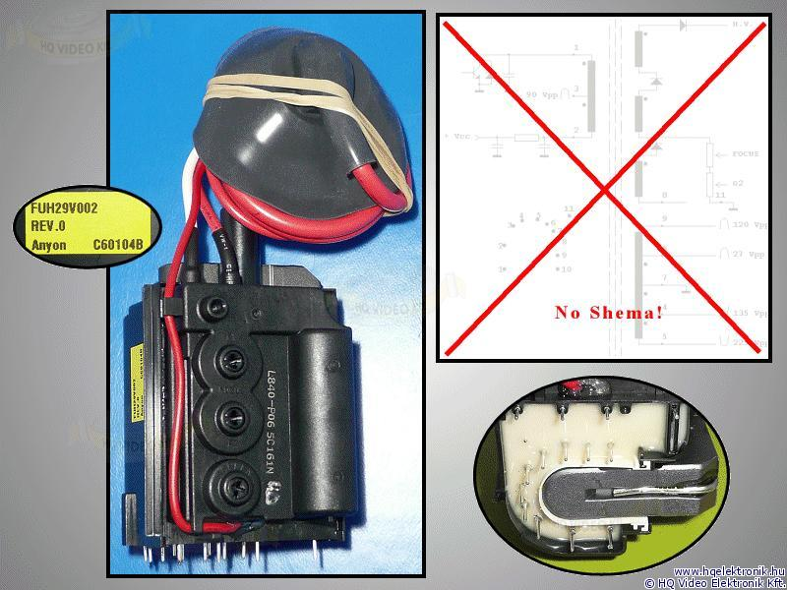

We have found the following devices which are able to use this article:
(Probably our list is not complete. Please do not hesitate
to contact us if you can not find the type of your device!)
Product | Type | Original
SAMSUNG | WS32Z308P | AA2600244A
SAMSUNG | WS32Z308PAXXEC | FUH29V002

