Since not much info can be found online, i spent quite some time and effort poking fine wires into the AGOX connector with a DMM to find out which pin is which. If you are interested, this is the pin-out info:
Pin Connections for AGOX to USB, Mono Audio Out and Video Out
Pin 1 - USB Pin 1
Pin 2 - USB Pin 2
Pin 3 - USB Pin 4, Audio Ground,Video Ground
Pin 4 - USB Pin 3
Pin 5 - USB Pin 4, Audio Ground,Video Ground
Pin 6 - Audio Sig
Pin 7 - Video Sig
Pin 8 - USB Pin 4, Audio Ground,Video Ground
Corresponding Connecting Poles at the Back
--[a]--[b]----
----[c]--[d]--
--------------[i]
--[e]--[f]----
----[g]--[h]--
Pin 1 - a
Pin 2 - e
Pin 3 - c
Pin 4 - g
Pin 5 - b
Pin 6 - f
Pin 7 - d
Pin 8 - h
N/C - i
Note that Pin 1 refers to the rightmost pin when viewed from in front (imagine u are the receptacle and this connector is coming into you) or the leftmost pin when viewing the back (where you will be seeing the connecting poles)
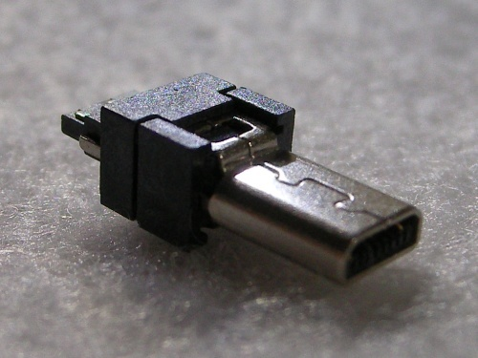
AGOX connector.

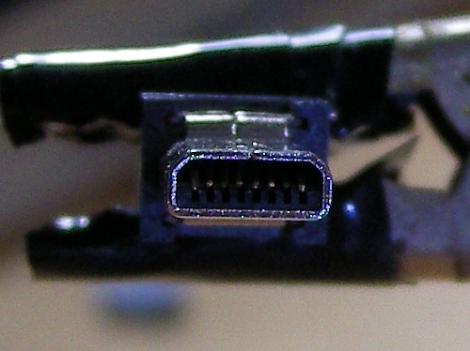
Inside got 8 pins.

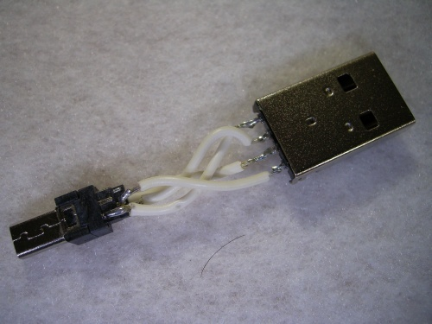
Wired them up together.

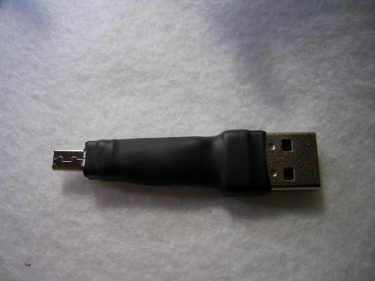
Heat shrink tubed it.
View/Post Comments (1)

