Tantalum Capacitor Codes.
How to read a Tantalum capacitor with Numeric coding (Sample 10µF, 25V).
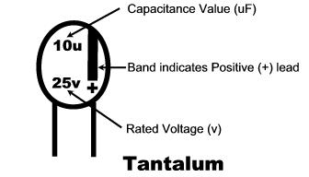

How to read a Tantalum capacitor with Color coding (Sample 6.8µF, 6.3V).
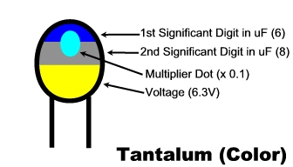
Tantalum Color Code Table.
Color | 1st Digit | 2nd Digit | Multiplier Dot | Voltage
Black | 0 | 0 | x 1 | 10V
Brown | 1 | 1 | x 10 | -
Red | 2 | 2 | x 100 | -
Orange | 3 | 3 | - | -
Yellow | 4 | 4 | - | 6.3V
Green | 5 | 5 | - | 16V
Blue | 6 | 6 | - | 20V
Violet | 7 | 7 | - | -
Gray | 8 | 8 | x 0.01 | 25V
White | 9 | 9 | x 0.1 | 3V
Pink | - | - | - | 35V

Common Capacitor Working Voltages (DC), By Capacitor Type.
Ceramic | Electrolytic | Tantalum | Mylar (Polyester) | Mylar (Metal Film)
 | 10V | 10V
16V | 16V | 16V
 |  | 20V
25V | 25V | 25V
 | 35V | 35V
50V | 50V | 50V | 50V
 | 63V
100V | 100V |  | 100V
 | 160V
 |  |  | 200V
 | 250V |  |  | 250V
 | 350V
 |  |  | 400V | 400V
 | 450V
600V
 |  |  |  | 630V
1000V

