KYE对码说明
1、鼠标对码步骤Mouse Pairing Steps：
- 将接收器插到电脑上，打开如图一中的对码软件，弹出对码窗口如图二所示；
Connect the Receiver to the USB port of the PC, then open the paring software as Pic.1, then it will open a window like Pic.2
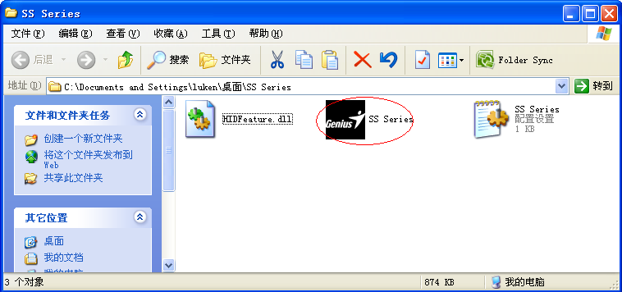
打开此软件
Open this software
图一:打开对码软件 (Pic.1)
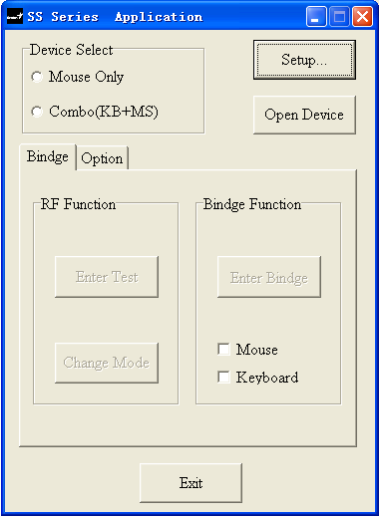
图二:对码软件打开后图示 (Pic.2)

- 点击“SETUP”然后弹出一个VID/PID设定窗口，确定其套装(键盘+鼠标)的VID/PID值，如图三所示:
Click “SETUP”,then it will open a “Device VID/PID SETUP” window like Pic.3, please confirm the combo’s VID/PID.
点击此按钮 Click this button

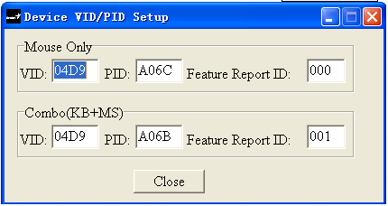

此处VID/PID值应为04D9/A06B
VID/PID should be 04D9/A06B
图三 (Pic.3)

- 在“Device Select”处勾选“Combo(KB+MS)”选项，然后点击“Open Device”,如图四；
Please select“Combo(KB+MS)”at Device Select”,then click “Open Device”, like Pic.4
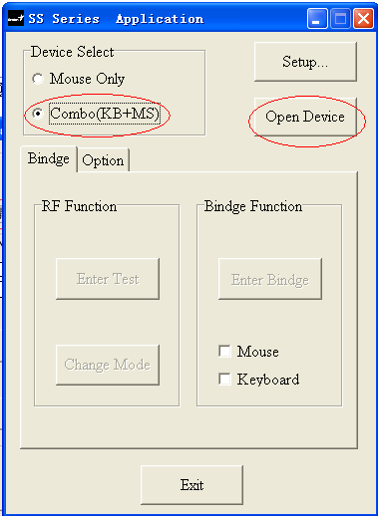 图四 (Pic.4)
选中此选项
Select this item
点击此按钮
Click this button

- 点击图五中的“Enter Binge”按钮，将鼠标靠近接收器20cm以内的距离，同时按住鼠标的“左、中、右”三个按键，再打开鼠标电源开关，待3秒后松手（此步动作需在30秒内完成），如果指示灯灭掉后鼠标能正常使用，即表示鼠标对码成功；
    - Click the “Enter Binge”button as showing in Pic.5;
    - Keep the mouse close to the receiver within 20cm;
    - Keep pressing down “left/middle/right” 3 buttons at the same time, and switch the power buttonto “on”, and release these 3 buttons after 3 seconds. (Remarks: this step action should be finished within 30 seconds)
    - The LED on the mouse goes off, the pairing work is completed
The mouse is now ready to operate

- 若鼠标对码不成功，请按步骤4重新对码
In the event of a fault, please repeat Step 1.4.
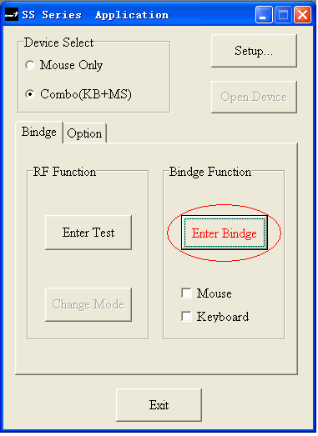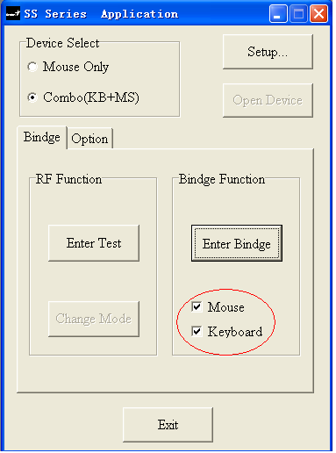
此处对成功后自动打“√”
If pairing successful, here it will choose “√” automatically

点击此按钮
Click this button

图五 (Pic.5)
。
2、键盘对码步骤Keyboard Pairing Steps：
2.1键盘的对码步骤与鼠标对码的1-3步骤相同，只是第4步有区别，具体操作见2.2；
Same steps as Mouse Pairing step 1.1~1.3
2.2点击如图五中的“进入对码”按钮，将键盘靠近接收器20cm以内的距离；同时按住键盘上的“左边Shift + ESC”2个按键，再将电池装入键盘上电，待3秒后松手（此动作需在30秒内完成），键盘能正常使用，即表示键盘对码成功；
    - Click the “Enter Binge”button as showing in Pic.5;
    - keep the keyboard close to the receiver within 20cm;
    - Keep pressing down the left Shift keycaps and Esc keycaps at the same time, and install the right batteries into the keyboard, and then release these 2 keycaps after 3 seconds. (Remarks: this step action should be finished within 30 seconds)
    - The pairing work is completed and the keyboard is now ready to operate

2.3若键盘对码不成功，请按步骤2重新对码。
In the event of a fault, please repeat Step 2.2

