Stereo FM transmitter using BA1404
admin
February - 17 - 2011
19 Comments

Stereo FM transmitter circuit using BA1404.
Notes.
A high quality stereo FM transmitter circuit is shown here. The circuit is based on the IC BA1404 from ROHM Semiconductors. BA1404 is a monolithic FM stereo modulator that has built in stereo modulator, FM modulator, RF amplifier circuitries. The FM modulator can be operated from 76 to 108MHz and power supply for the circuit can be anything between 1.25 to 3 volts.
In the circuit R7, C16, C14 and R6, C15, C13 forms the pre-emphasis network for the right and left channels respectively. This is done for matching the frequency response of the FM transmitter with the FM receiver. Inductor L1 and capacitor C5 is used to set the oscillator frequency. Network C9,C10, R4,R5 improves the channel separation. 38kHz crystal X1 is connected between pins 5 and 6 of the IC. Composite stereo signal is created by the stereo modulator circuit using the 38kHz quartz controlled frequency.
Circuit diagram.
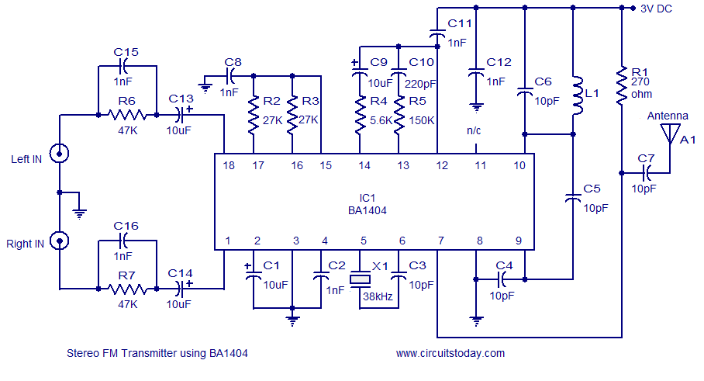
Stereo FM transmitter circuit
Notes.
- Assemble the circuit on a good quality PCB.
- Powering the circuit from a battery will reduce noise.
- Use an 80 cm copper wire as antenna.
- For L1 make 3 turns of 0.5mm dia enamelled copper wire on a 5mm dia ferrite core.

